Freestanding Combi Units

Warranted - Brand New, Factory Packed, Fridge/Freezer Combi Units. All Manufacturered in Europe by Brand Leader.

Offered in full Truck/Container Loads of 80 units

MODEL NUMBER |  | 1 LOAD  PRICE EACH | 2/3 LOADS  PRICE EACH | 4 LOADS  PRICE  EACH | MULTIPLE  LOADS  BEST PRICE
FK274BUW-02AM |  | € 167.50 | € 165.00 | € 160.00 | Special Offer Price
FK264BUW-02AM |  | SOLD | SOLD | SOLD | SOLD

There is a restriction on sales into some EU Countries. Please contact the sender of this offer for further information.

NORMAL TERMS & CONDITIONS OF SUPPLY APPLY

OVER 900+ UNITS IN STOCK – IMMEDIATE COLLECTION

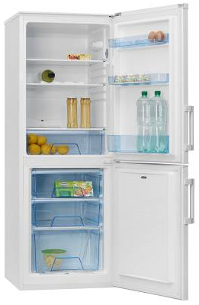
FOR MOQ AND PRICE – SEE ABOVE
SPECIAL OFFER PRICE FOR LIMITED PERIOD ONLY
EMAIL: office@stockassetmanagement.com
All prices are quoted on an EXW basis at our warehouse facilites in Warsaw, Poland, transport is at the buyers account.
This is an stock item, once it’s gone then it’s gone

